# Unified GraphDB schema for Plans from multiple providers

## Plans under consideration:

* StraightTalk : Platinum Unlimited - <https://www.straighttalk.com/all-plans>
* Verizon : Unlimited Ultimate - <https://www.verizon.com/plans/unlimited/>
* Tracfone : $40 Unlimited Talk and Text, 20GB of Data Hotspot Capable and ID Protection / 30 Days - <https://www.tracfone.com/phone-service-plans>

## Graph Visualization:

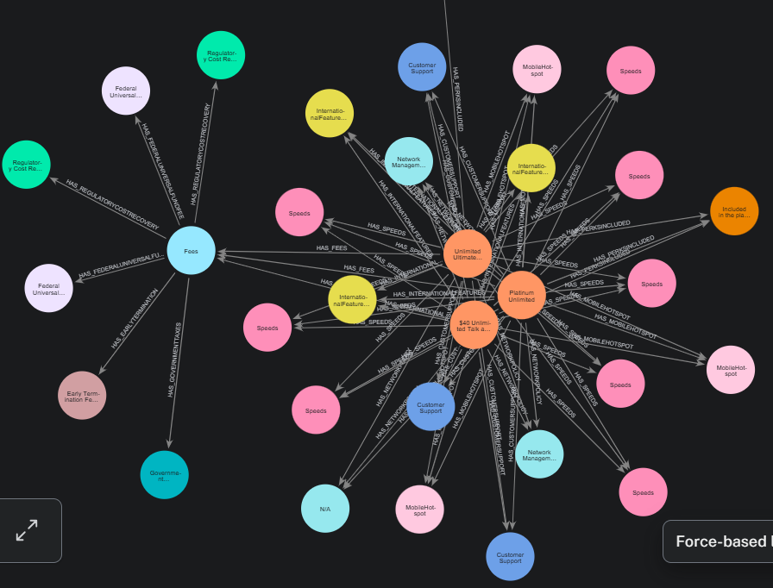

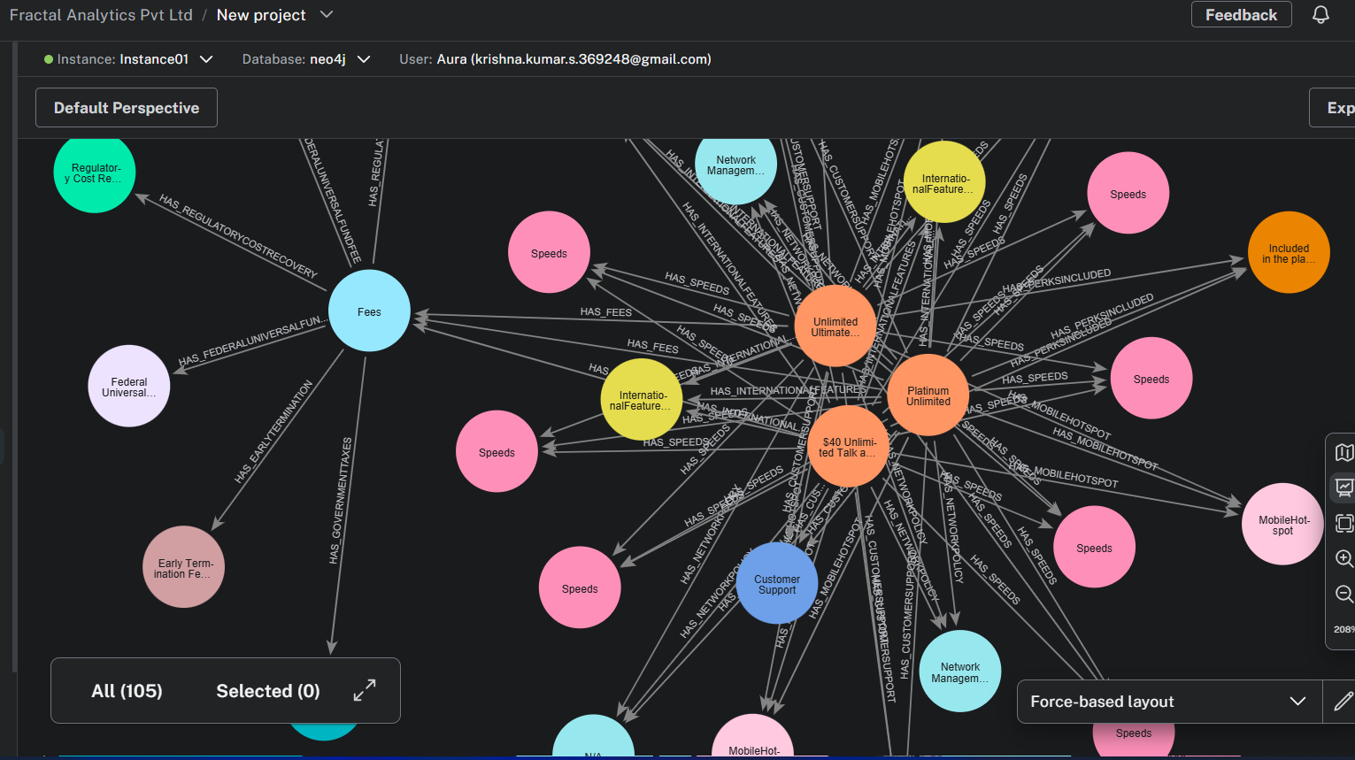

## Queries:

### Scenario 1:

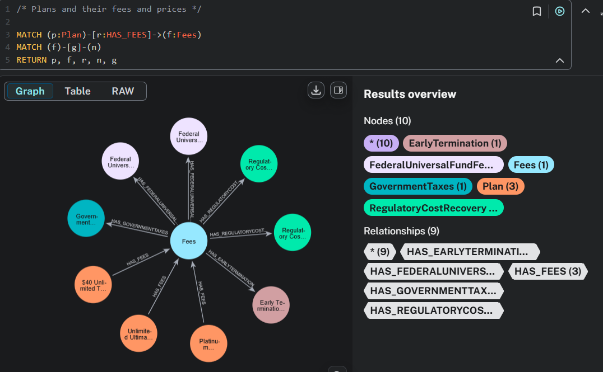

### Scenario 2:

##### Cypher Query:

MATCH (n:Plan)

RETURN labels(n) AS label, properties(n) AS properties

UNION ALL

MATCH (n:InternationalFeatures)

RETURN labels(n) AS label, properties(n) AS properties

UNION ALL

MATCH (n:PerksIncluded)

RETURN labels(n) AS label, properties(n) AS properties

##### Neo4j response:

label,properties

[Plan],"{

streaming_quality: N/A,

pricing_tier_price_per_line: 40.0,

bring_your_own_device_offer: Discounts and bundling options are available when using your own equipment (e.g., modem/router).,

upgrade_offer: N/A,

data_included: 20 GB,

price_lock_years: 0.0,

provider: Tracfone Wireless,

discounts_and_bundles_link: https://www.tracfone.com/discount-and-bundles,

additional_data_charges: $0.00 (no extra charge for additional data),

pricing_tier_price_notes: [Cost: $40.00 per 30-day cycle],

price_with_auto_pay: false,

description: Plan,

pricing_tier_span_months: 1.0,

network_access: [5G, 4G LTE],

monthly_price: $40.00,

connected_device_discount: Discounts and bundling options are available when combining with other Tracfone services (video, phones, wireless services),

disclosure_title: Mobile Broadband Consumer Disclosure,

pricing_tier_num_lines: 1.0,

premium_data: true,

plan_name: $40 Unlimited Talk and Text, 20GB of Data (Hotspot Capable) â€” 30 Days

}"

[Plan],"{

streaming_quality: Up to 4K Ultra High Definition on 5G Ultra Wideband

Up to 1080p on 5G or 4G LTE,

pricing_tier_price_per_line: 90.0,

bring_your_own_device_offer: $540 credit with a new Unlimited Ultimate line.,

upgrade_offer: New and existing customers get Verizonâ€™s best in-market trade-in deals.,

data_included: Unlimited premium data on Verizonâ€™s 5G Ultra Wideband, 5G, and 4G LTE networks.,

price_lock_years: 3.0,

provider: Verizon,

discounts_and_bundles_link: N/A,

additional_data_charges: Speeds reduced after 200 GB/month to:

6 Mbps on 5G Ultra Wideband

600 Kbps on 5G / 4G LTE,

pricing_tier_price_notes: [These prices are before any discounts., $10/month discount when using Auto Pay with ACH or the Verizon Visa Card and enabling paper-free billing., Net price after combining with Auto Pay discount is $65/month per line (for single-line users).],

price_with_auto_pay: true,

description: Plan,

pricing_tier_span_months: 1.0,

network_access: [5G Ultra Wideband, 5G, 4G LTE],

monthly_price: 90,

connected_device_discount: Up to 50% off two lines for eligible devices (smartwatch, tablet, hotspot, in-car Wi-Fi).,

disclosure_title: N/A,

pricing_tier_num_lines: 1.0,

premium_data: true,

plan_name: Unlimited Ultimate Plan

}"

[Plan],"{

streaming_quality: unspecified,

pricing_tier_price_per_line: 65.0,

bring_your_own_device_offer: Details can be found here.,

upgrade_offer: unspecified,

data_included: Unlimited data included with the monthly price,

price_lock_years: 0.0,

provider: Straight Talk Wireless,

discounts_and_bundles_link: Details can be found here.,

additional_data_charges: no additional charges for extra data usage.,

pricing_tier_price_notes: [$60/mo offer for the first 3 months with Auto Pay],

price_with_auto_pay: false,

description: Plan,

pricing_tier_span_months: 1.0,

network_access: [5G Ultra Wideband, 5G, 4G LTE],

monthly_price: 65.00,

connected_device_discount: Details can be found here.,

disclosure_title: Privacy policy details are available here.,

pricing_tier_num_lines: 1.0,

premium_data: true,

plan_name: Platinum Unlimited

}"

[InternationalFeatures],"{

description: InternationalFeatures,

throttle_speed: N/A,

high_speed_data_gb: 20.0,

roaming: N/A,

intl_calling: N/A

}"

[InternationalFeatures],"{

description: InternationalFeatures,

throttle_speed: 1.5 Mbps,

high_speed_data_gb: 15.0,

roaming: Unlimited talk and text in 210+ countries.,

intl_calling: 300 minutes/month of international calling to one selected country.

}"

[InternationalFeatures],"{

description: InternationalFeatures,

throttle_speed: unspecified,

high_speed_data_gb: 0.0,

roaming: unspecified,

intl_calling: unspecified

}"

[PerksIncluded],"{

description: Included in the plan offering (no specific technical detail provided on protection features).,

type: ID Protection

}"

[PerksIncluded],"{

description: Includes Disney+, Hulu, and ESPN+ (with ads).,

type: Streaming

}"